Algebra 1: Unit 3, Lesson 5

- A local supermarket recorded the number of items purchased along with the total price of each receipt. The data is displayed in the graph.
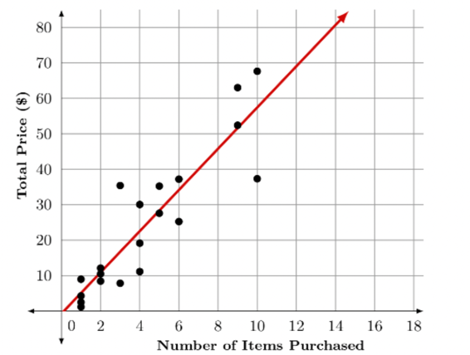
What type of slope does the trend line have?
positive

- A research scientist is studying the growing patterns of Emperor penguins. The researcher uses the equation $y=6.8x+3$ to model the height, $y$, in centimeters (cm), of an average Emperor penguin $x$ weeks after birth.
How many centimeters tall is the average penguin at birth?
3

- The relationship between the outside temperature, in degrees Fahrenheit (∘F), and the number of jackets sold is shown in the graph.
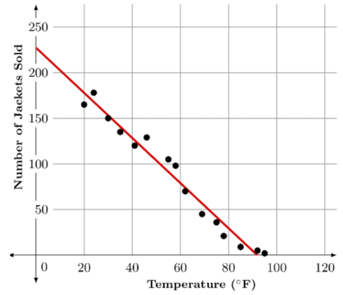
As the outside temperature increases, the amount of jackets sold ____________.
decreases

